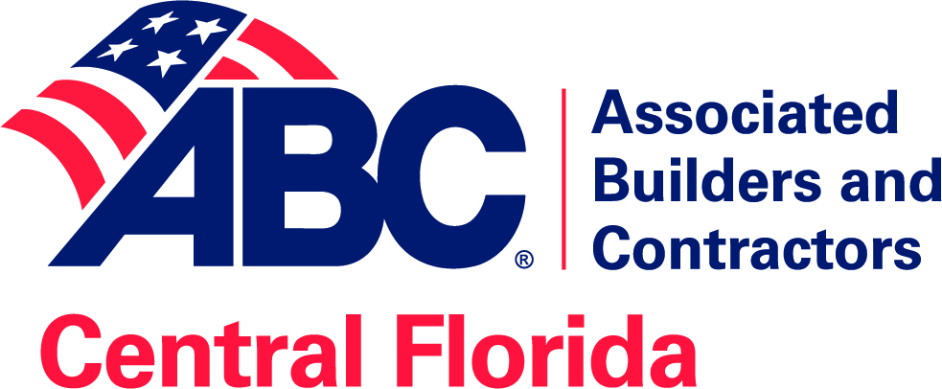

2020
Board Orientation

Tips on being a successful Board member
The Board Orientation is designed to help define what being a leader in ABC is about and tips on being a successful Board member. Each Board member has a responsibility to themselves, each other and the organization to learn what is expected of a Board member.

Agenda

What is ABC?
What is a Board?
What does a Board do?
Board Structure
Board Dream Team
Board Duties
ABC’s purpose
Strategic plan
Chapter Operations
Finances
Financial Health of the Organization

What is ABC?
ABC is a 501(c)(6) not for profit trade association that is chartered as a chapter of the National ABC association. Central Florida Chapter ABC is one of 70 Chapters nationwide. There are five Chapters in the State of Florida. Florida is one of the States that does have a State organization, called ABC of Florida.
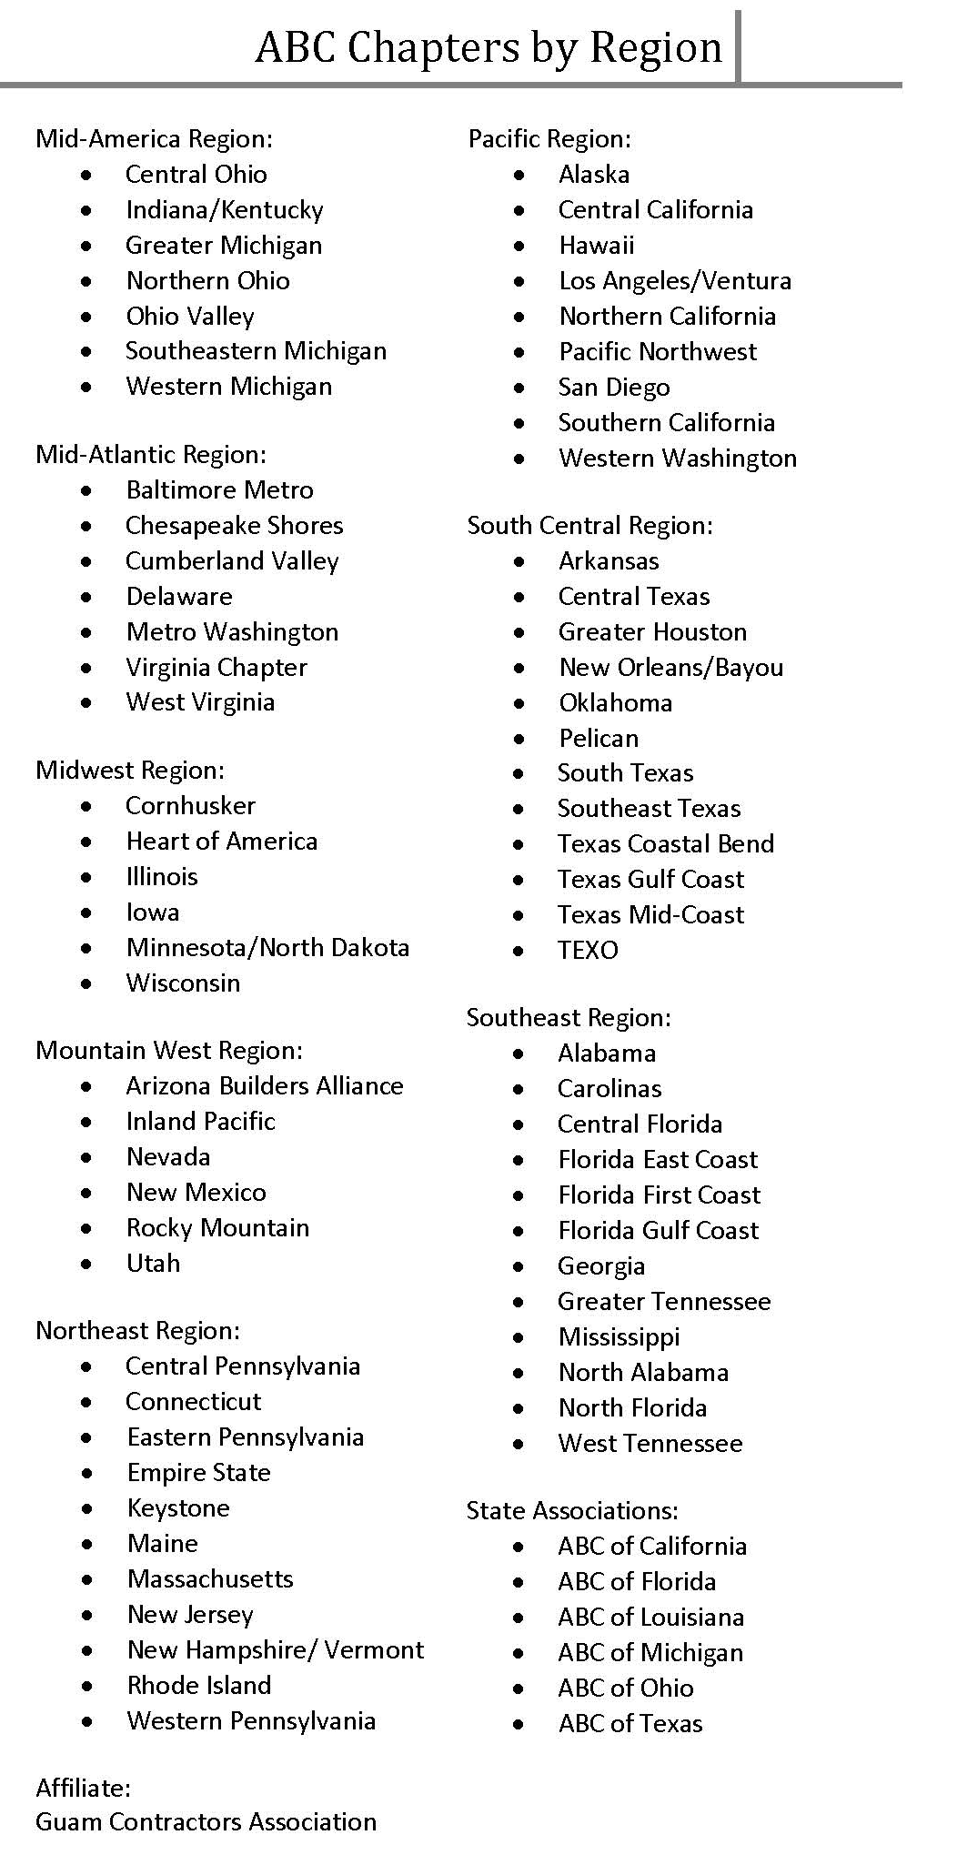
National ABC:
www.abc.org

Chapter locator:
https://www.abc.org/chapter-locator

ABC of Florida:
http://www.abcflorida.com

Central Florida Chapter ABC
serves the five counties:
- Lake
- Orange
- Osceola
- Seminole
- Volusia

Membership is by company, not individual, therefore the value proposition is focused more on benefiting companies, but still offers services to benefit individuals. With a company membership, all employees are eligible for member benefits.

The core purpose of ABC is to advance and defend the principles of Merit Shop in the construction industry and to provide members and their employees with an opportunity to succeed.

ABC Merit Shop Philosophy

Associated Builders and Contractors, Inc. is the voice of the merit shop in the construction industry. We accept the responsibility for making that voice heard. We believe the merit shop movement is a movement for the betterment of the individual... the construction industry... and the nation.

We believe in the system of free enterprise and open competition.

We believe employees and employers should have the right to determine wages and working conditions through either individual or collective bargaining, as they choose, within the boundaries of the law.

We believe the employer must have concern for the general welfare of the employee and that there must be a fair compensation for work performed. At the same time, we believe that the employee has an obligation for satisfactory performance of assigned work.

We support sound legislation in the areas of workers compensation, safety and unemployment compensation.

We believe legislation that embraces fair play for employer and employee is essential to the preservation of our free enterprise system.

We believe the law should protect the right of employees to work regardless of race, color, creed, age, sex, national origin or membership or non-membership in a labor organization. We believe work opportunities should be made available to all legal residents and we support programs toward this end.

We oppose violence, coercion, intimidation and the denial of the rights of employees and employers.

We believe it is incumbent upon all branches of government to be responsible stewards of taxpayer dollars and we believe that government should award contracts only to the lowest responsible bidder. We oppose unjust pressure to violate these principles.

We believe monopolies or any kind of price or wage fixing, in either the public or private sector, are detrimental to our system of free enterprise.

We believe the destiny of all Americans can be best served by cooperation, reconciliation and following the tenants of free enterprise and a democratic government. We believe business leaders can best preserve these tenets by becoming active in politics and civic affairs.

Core Values
ABC values economic freedom within a free-market economy, with open and fair competition and diverse participants constantly striving to achieve the highest levels of personal and company performance.

ABC values the highest levels of personal and corporate standards of behavior characterized by responsibility, accountability and integrity, with demonstrated personal and industry professionalism by all participants.

Vision
The Vision of ABC is an environment in which people and companies succeed based on free-enterprise principles within the free-market system.

Mission
ABC will continually strive to be the leading voice promoting free enterprise within the construction industry. ABC will promote and defend the merit shop philosophy. This philosophy encourages open competition and a free-enterprise approach to construction based solely on merit, regardless of labor affiliation.

Core Purpose
The Core Purpose of ABC is to advance and defend the principles of the merit shop in the construction industry and to provide members and their employees with an opportunity to succeed.
https://www.abc.org/ABC/About-ABC/ABC-Philosophy

What is a Board?
ABC is a non-profit corporation where ownership is through the members – not the staff, not the Board, nor any individual. The Board of Directors are elected by the members to govern the association according to the bylaws.

What does a Board do?
  - Sets policy
  - Sets direction/strategic plan
  - Hires President & CEO
  - Establishes a balanced budget
  - Has fiduciary responsibility

Therefore, in simple terms a Board of Directors governs but does not manage day-to-day operations.

How is the CFC ABC Board Structured?
Officers
Directors
- At Large members (12)
- Associate/Supplier members (4)
- Owners (2)
- Outlying county members
Advisors to the Board
Specialists who bring particular talents to the organization
- Treasurer – monitors & reports on finances (elected)
- General Counsel (appointed, does not vote)

Officers/The Executive Committee consists of
  - Chair –
    - Sets the board meeting agenda
    - provides leadership
    - ensures that the board functions properly
    - ensures that there is full participation during meetings
    - ensures that all relevant matters are discussed
    - ensures and that effective decision are made and carried out
  - Chair-elect – acts for the Chair when necessary or as assigned
  - Vice Chair & Secretary – acts for the Chair when necessary, responsible for document recording
  - Vice Chairs (2) – One of which is a Supplier/Associate member
  - Immediate Past Chair

Board Terms
Executive Committee one-year term of office
Treasurer (Certified Public Accountant) one-year term of office

Directors three-year terms, which are staggered
Four at-large Directors 1 year remaining
Four at-large Directors 2 years remaining
Four at-large Directors 3 years remaining
Two Supplier/Associate Directors 3 years remaining
Two Supplier/Associate Directors 1 year remaining

One Director may also be appointed from each Outlying County
(Brevard, Lake, Polk, Volusia, and Osceola Counties); to serve annual terms.

Up to two Owner Directors may be appointed to serve a year-year term.

Board Organization
Membership at large elects the Board of Directors who oversee the Committees and hire the President & CEO.

The Board / CEO Team
- The Board sets strategic policy and direction, based on mission
- The President & CEO makes it happen
- Honest and open communication is a two-way street and is necessary for the team to work well together

What does a Board Dream Team look like?
- People with knowledge & experience, ideally company owners and key decision makers, finance and operations, to name a few.
- Balanced membership – subcontractors, general contractors, suppliers and associate members that represent a cross section of the membership.
- People who think strategically and ask the important questions.
- Members who set performance expectations and then hold each other accountable
- Visible Leaders of the association
Board of Directors’ Duties & Responsibilities

Fiduciary Responsibility
The law holds the Board of Directors responsible for the actions of the Association, and they have an obligation to act in the best interests of the association.

Not for profit board directors have three fiduciary responsibilities, and each of them is very important. It’s critical for board directors to practice them in word and in deed, and to make sure that their fellow board directors do as well. The three fiduciary responsibilities of all board directors are the duty of care, the duty of loyalty and the duty of obedience, as mandated by state and common law.

It’s important that all board directors understand how their duties fall into each category of fiduciary duties. Not understanding fiduciary duties — or not being well-informed about them — doesn’t relieve board directors from any obligations or liabilities they may face if they fail to fulfill these important duties.

Board directors are legally responsible for managing a not for profit entity’s assets. Board directors who diligently perform their fiduciary duties responsibly protect the organization’s reputation, which also falls into the category of a fiduciary duty.

Duty of Care
- A Board of Director should be active in organizational planning and decision making.
- A Board of Director should exercise reasonable care in making decisions for the organization.

Duty of care means that board directors must give the same care and concern to their board responsibilities as any prudent and ordinary person would. This means board members should be actively participating in board meetings and on committees. It also means that they should be actively working with other board directors to advance the organization’s mission and goals. They can fulfill their responsibilities by overseeing and monitoring the nonprofit’s activities. Board directors should be able to read and understand financial reports and be willing to question expenditures and examine variances. They are also responsible for strategic planning and achieving the nonprofit’s short- and long-term goals.

Duty of Loyalty
- A Board of Director should never use information gained through their position for personal gain.
- A Board of Director should always act in the best interests of the organization.
- A Board of Director should avoid conflicts of interest or the appearance of conflicts.
- A Board of Director should follow ABC’s ethics policies.

Duty of Obedience
- A board member must be dedicated and knowledgeable to the mission and goals.
- Make sure ABC is abiding all laws and regulations.

Duty of obedience means that board directors must make sure that the not for profit is abiding by all applicable laws and regulations and doesn’t engage in illegal or unauthorized activities. The duty of obedience also means that board directors must carry out the organization’s mission in accordance with the purpose they stated in getting qualified as a not for profit organization.

Duties - Follow the Law & Rules
- Federal and State laws
- Chapter Bylaws
- Policies and Procedures
- Follow confidentiality policies
- Anti-trust policy
- Anti-discrimination policy
- Conflict of interest policy
- Whistle Blower policy
- Document retention policy

Legal advice should not be ignored.

Responsibilities

Responsibilities
Create Strategic Plan
  - Annual goals
  - Long term goals
  - Ensure adequate resources

Responsibilities
Be informed about ABC’s
  - Mission & Purpose
  - Services
  - Programs
  - Plan & Policies
  - Strategic Plan
  - Annual Goals

Responsibilities
- Attend all scheduled board meetings
- Less than 3 absences
- Directors are responsible for Board decisions whether or not they are in attendance.
- Review agenda and supporting materials prior to board and committee meetings

Accountability breeds response-ability
– Stephen R. Covey

Responsibilities are in place for accountability.

Accountability is critical for achieving winning results.

Responsibilities – 2020 Expectations
- Chapter PAC
- National PAC or FEA
- New member recruitment
- Retention effort
- VIP Sponsorship or equivalent
- Committee participation (not liaison)
- Company committee participation
- Event Attendance
- Legislative Conference
- State or National ABC meeting

Why is ABC here? What is ABC’s purpose?
Purpose: Create common community success
Our Niche: Through advocacy, education and connectivity

Marketing Strategy
Target Market Demographics
- commercial construction contractors
- 20+ employees
- over $3 million in annual revenue
- who are seeking or doing business with ABC members

Target Market Geographic
- located in or doing business in the five county areas around Orlando
  - Lake
  - Orange
  - Osceola
  - Seminole
  - Volusia

Target Market Philosophical
- community minded
- believes in free enterprise
- produce a quality service
- have merit shop mentality
- get involved
- gives back to the industry

Uniques
- Connect
  - Networking
- Educate
  - Industry specific
  - Workforce development
- Advocate
  - protecting your business
- Compete
  - Offering tools and resources for competing
  - Help increase profitability

Why is this important?
ABC focuses its programs and services on the target market.

Strategic Plan
Having a strategic plan is essential for the Association’s success.

The Strategic Plan:
- Assesses where the organization is.
- Define goals for where it should go.

As you remember, one of the responsibilities of the Board is to create the Strategic Plan and the direction of the Association.

So, how does the strategic plan get done and by whom?

Chapter Operations
- Things are accomplished through committees and staff.
- All committees in a not for profit are units of the board, both doing work for and reporting to the board.

Why Committees are Essential
- The Board cannot do everything themselves
- Involve members
  - in development and in delivery of services
- Engage members
- Represent member opinions

- Give members the opportunity to interact
- Forum for presenting multiple points of view
- Training ground for future leadership

Committees Types
- Standing Committees are specified in the organization’s By-Laws:
  - Nominations
  - Finance & Audit
  - Investment
  - Workforce
Standing committees are normally made up of the Board members.

- Program & Service Committees

  - Have regular members & board members
  - Short term or on-going
- Task Force
  - Formed to work on a single define task
  - Short term

Committee organization:
Connect / Business Development
Excellence in Construction Awards
Golf Committee
Poker Run Committee
Programs Committee
Special Events Committee

Advocate / Legislative
Legislative/PAC Committee

Educate / Training & Development
ABC/UCF Student Chapter Comm.
Safety Committee
Workforce Committee (formerly AEF)
Young Professional Committee

Membership
Membership Development

Governance
Finance & Audit Committee
Nomination Committee

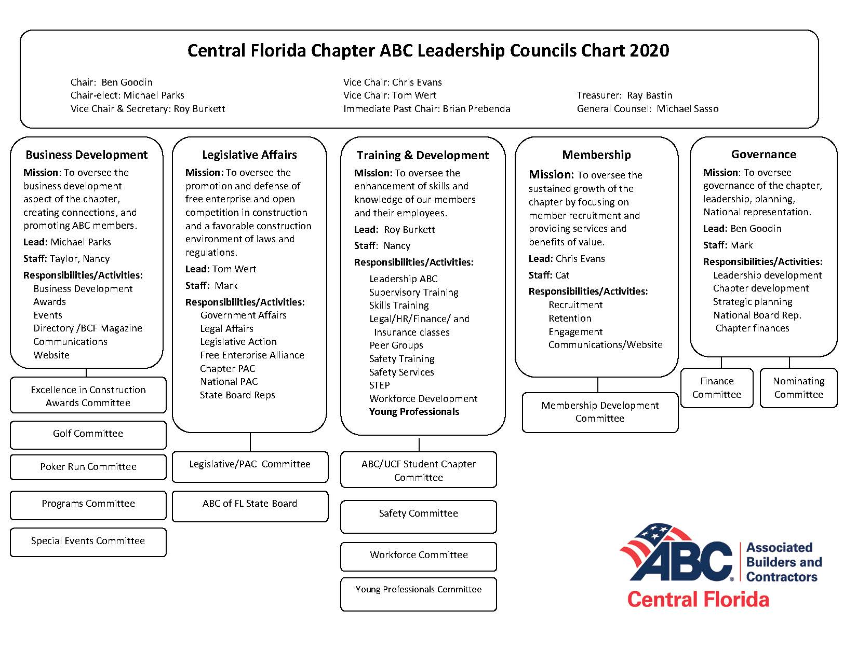
Committee organization:

Finances
Part of the Board of Directors’ fiduciary responsibilities is to ensure adequate resources includes finances.
- Income
- Expense
- Financial Health

Income
Where does ABC’s funds come from?
The corporation’s sources of funds come from:
- Membership dues
- Program fees
- Sponsorships
- Donations
- Funds received from fund raising activities
- Rentals and leasing income
- Product sales
- Investment income

How are funds spent?

Program Expenses
- State and National dues
- Educational program expenses
- Meetings expenses
- Publication expenses
- Cost of goods for resale

General Administrative Expenses
- Personnel
- Travel, Meetings & Conferences
- Communications Expense
- Occupancy Expenses
- Office Expenses
- Other G&A Expenses

Other Expenses
- Depreciation
- Workforce Contributions

Financial Health
Association financial health can be determined based on surplus, cash flow, and membership retention.

- Profitability
Not for profit is a tax status and not a business plan.
The plan is to break even or end the year with a surplus.
Each year the board creates a balanced budget (break-even or with a surplus)

- Cash Flow
  - CFC ABC has $1,482,000 in checking accounts, money market accounts and an investment account.
  - ABC owns this building and the land without a mortgage.
  - These along with other fixed assets (such as the contents) has a value of $1.7 million.
  - CFC ABC has total company assets equaling $3.4 million.
  - CFC ABC’s finances Expenses are accrued or on a monthly basis for specific programs and events.
  - Current liabilities = $1,058,000 million, of which $937,000 is unearned income, which will show up on the financials in the month of the scheduled program or monthly for membership dues.
  - Unrestricted Retained Earnings or equity is $2.3 million.

NOTE: ABC’s balance sheet reports the organization's assets (what is owned) and liabilities (what is owed). The net assets (also called equity, capital, retained earnings, or fund balance) represent the sum of all the annual surpluses or deficits that has accumulated over its entire history.
Membership Retention
CFC ABC has maintained or exceed an average retention of 87% for the last four years. Ending the year with 428 member companies, 81 which were new for 2019.

Retention by percentage of member companies

Financials
- ABC’s fiscal year is from January 1 through December 31 of each calendar year.
- Accrual method.
- Monthly financials are created to review Balance Sheet items and Profit & Loss for each department and overall corporation bottom line.

Monthly financials contain
  - Balance sheet
  - Profit & loss compared to budget
  - Profit & loss compared to previous year
- The end-of-year financials are reviewed by an outside accounting firm each year, with an audit every third year.
Summary
The handbook is an outline of what a Board member needs to know, understand, and act on.

- What ABC is -
- What a Board is -
- What a Board does -
- How a Board is structured
- What makes a Board Dream Team
- The duties and responsibilities of a director
- ABC’s purpose and reason for existing
- The importance of strategic planning
- How Central Florida Chapter ABC operates
- The financial health of Central Florida Chapter ABC

Understanding these elements will help you become a successful Board member and help ABC succeed.

It will also make this a rewarding experience for you and the organization in 2020.

