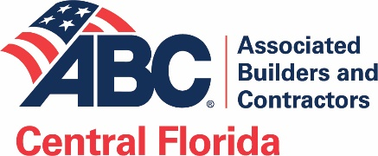
CFC ABC
Board Organization

Membership at Large elects

Board of Directors
Executive Committee
Chairman of the Board Ben Goodin
Chairman-elect Michael Parks
Vice Chairman & Secretary Roy Burkett
Vice Chairman Chris Evans
Vice Chairman Tom Wert
Immediate Past Chairman (not elected) Brian Prebenda

Advisors to the Board
General Counsel (Attorney) (not elected) Michael Sasso
Treasurer (Certified Public Accountant) Ray Bastin

Directors at Large
Twelve At-large Directors

Jason Albu
Rob Allen
Bryan Boykin
Charles Bracco
Juan Garcia
Derek Gregg
Julie Holmes P.E.
C. L. Janeski
Michael Jordan
Travis Kolbjornsen
Noble Thomas
Carlos Velasco

Four Supplier/Associate Directors
David Nabavi
Debbie Rodriguez
Scott Scruby
Matt Walton

One Owner Director Chad Tinetti

One Director may also be elected from each Outlying County
Osceola Earl Lomas
Polk Chip Tucker
Board hires
President & CEO Mark Wylie
Board hires

