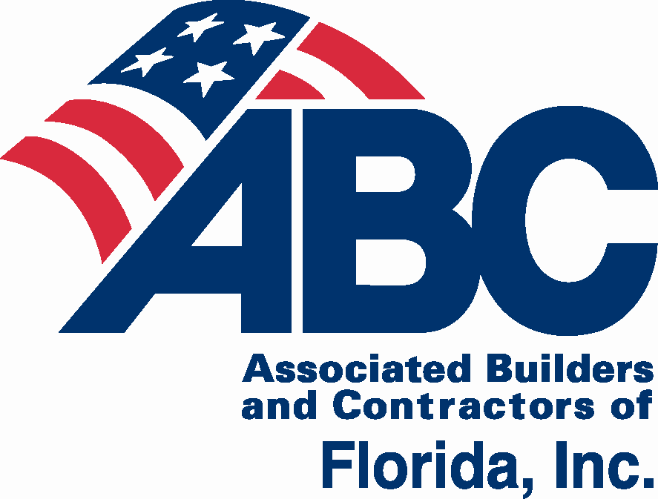
2019 ABC of Florida
State Convention
This event supports state-wide legislative and political efforts for ABC members.
July 25-27, 2019

The ABC of Florida State Convention gives you an opportunity to make connections and develop relationships with peers from all five Florida ABC Chapters, while enjoying the Florida’s Gulf Coast. Reserve your room for Thursday, Friday and Saturday nights at the Lido Beach Resort.

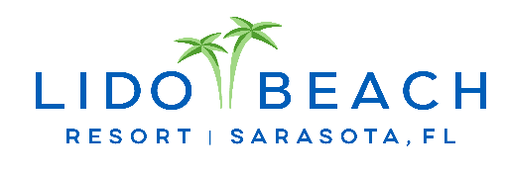
Lido Beach Resort
700 Benjamin Franklin Drive
Sarasota, FL 34236
800-441-2113
www.lidobeachresort.com

Events & Activities Schedule
Thursday, July 25 1:00 p.m. – 5:00 p.m. Board Meeting
6:00 p.m. – 7:30 p.m. Opening Night & Legislative Reception
Friday, July 26 8:00 a.m. – 4:00 p.m. Planning Conference
6:00 p.m. Chapter Dinners
“A little party never killed Nobody” - Fergie
(Contact your Chapter Office)
Saturday, July 27 6:00 p.m. – 7:00 p.m. Final Night Reception
7:00 p.m. – 10:00 p.m. Dinner, Dancing, & Murder Mystery Party

Room Reservations
ABC of Florida has reserved a limited number of rooms at a discounted group rate, which is available while supplies last. The deadline for the group rate is June 24, 2019. After this date, there is no guarantee that rooms or the group rate will be available. Group rate is available prior and after the Convention’s date for these dates based on availability: 7/20 – 7/30.

ABC of Florida State Convention Group Room Rates:
For group rates, use the online reservation link or call 800-441-2113 and mention ABC of Florida Annual Convention. For online link and more details go to www.abccentralflorida.com/state-convention

Run of the house group room rate is $249
Beachfront Deluxe Kitchenette group room rate is $279
Beach View Junior Suites group room rate is $339
Beach View One Bedroom Suite group room rate is $409
Partial View Two King Two Bedroom Suite group room rate is $399
These rates include a $10 per room, per night resort fee. Self-parking is an additional $15 per day. No valet parking is available.

Group rates are available for registered convention attendees only.
Send your convention registration by May 31 to be entered in the final night raffle!

Deadline for Room at Group Rate: Monday, June 24, 2019.

Sponsorship Opportunities
ABC of Florida State Convention July 25-27, 2019

Hospitality Suite Sponsorships
Thursday, July 25 – Saturday, July 27
– Beverage Sponsor $750
Company logo on signage in hospitality suite
– Coffee Sponsor $500
Company logo on signage in hospitality suite
– Map Sponsor $250
Company logo on property map distributed in each registration package and on display in hospitality suite

Tote Bag Sponsor $150*

Company supplies a minimum of 150 heavy duty tote bags which meet ABC specifications.

Registration Package Sponsor $125*

Company supplies a minimum of 150 donated items.

Lanyard Sponsor $125*

Company supplies a minimum of 150 lanyards which meet ABC specifications.
*Sponsor fee plus shipping and handling charges (which is determined by actual charges incurred). Contact the CFC ABC office with specifics, regarding shipping, delivery, size, etc.
Opening Night Reception Sponsors
Thursday, July 25
– Legislator Sponsor $1,000
Company logo on signage during reception

– Reception Sponsor $1,000
Company logo on signage during reception

ABC of FL Planning Conference Sponsors
Friday, July 26
– Planning Conference Meeting Sponsor $500
Company logo on signage during planning conference
– Planning Conference Breakfast Sponsor $250
Company logo on signage displayed during breakfast and on tables
– Planning Conference Lunch Sponsor $250
Company logo on signage displayed during lunch and on tables

Final Night Sponsors
Saturday, July 27
– Sleuth Reception Sponsor $1,000
Company logo on signage at during reception

– Dying to Dance DJ Sponsor $1,000
Company logo on signage during dinner/dance

– Alibi Centerpiece Sponsor $500
Company logo on mini tent cards on each table
– Mystery Sponsor $500
Company logo on signage displayed during final night

The ABC of Florida State Convention helps support legislative and political efforts for ABC members.

Sponsorships are not exclusive except for the Tote Bag and Lanyard Sponsors but may be limited to two companies for some items.

In addition, sponsors will receive:
- Listing in the convention package with company logo (high resolution company logo required) or name
- Company name or company logo on Sponsor Banner displayed in Hospitality Suite and during Final Night
- After event, Sponsors’ company logos will appear on the email sent to participants with the website link to convention photos
- $1,000 sponsors will have the opportunity to speak during the final night event

ABC of Florida State Convention
Registration & Sponsorship Form

Lido Beach Resort | 700 Benjamin Franklin Drive| Sarasota, FL 34236
Hospitality Suite is open to all convention registrants.
Chapter (Check one):
Central FL East Coast First Coast Gulf Coast North FL
CONTACT PERSON’S NAME | PHONE
CONTACT PERSON’S COMPANY | E-MAIL
2019 Schedule
Thursday, July 25 | 11:00 a.m. – 5:00 p.m.  1:00 p.m. – 5:00 p.m. | Registration & Hospitality Suite  ABC of FL Board Meeting
 | 6:00 p.m. – 7:30 p.m. | Opening Night & Legislative Reception
Friday, July 26 | 7:30 a.m. – 4:00 p.m. | Registration & Hospitality Suite
 | 8:00 a.m. – 4:00 p.m. | ABC of FL Legislative Planning Conference  (includes breakfast, lunch, afternoon snack, coffee, soda & water)
 | 6:00 p.m. | Chapter Dinners (check with your Chapter Rep.)
Saturday, July 27 | 6:00 p.m. – 7:00 p.m. | Final Night Reception
 | 7:00 p.m. – 10:00 p.m. | Dinner, Dancing, & Murder Mystery Party
 | 5:30 p.m. – 10:00 p.m. | Children’s Night Out
Packages
1. Convention Package with Planning Conference $395 – includes Opening Night Reception, Planning Conference, Final Night Reception, and Dinner, Dancing, & Murder Mystery Party
2. Convention Package only (without Planning Conference) $295
Individual Registration
3A. Opening Night & Legislative Reception $125 | 3B. Children 12 and under $45
4. Planning Conference $100
5. Final Night Reception, and Dinner, Dancing, & Murder Mystery Party $200
6A. Children’s Dinner (12 and under) $57 buffet | 6B. $37 Chicken Tenders
Registration deadline: July 12, 2019.
After this date there will be a surcharge/late fee as follows: Package #1 - $75 late fee, Package #2 - $45 late fee, #3 - $15 late fee, #4 - $30 late fee, #5 - $30 late fee.
Codes: M= ABC member company employee; S = Significant Other/Spouse/Guest of ABC member (Adult/Teen); C – Child 11 & under
M/S | Name (please print/type for badges): |  | Email – please include email for all adults to receive updates and other notices | Mobile # | Circle one package (1 or 2)  or all Individual Events (3, 4, 5) | Child  Age | Total per person
 |  |  |  |  | 1 2 3A 3B 4 5 6A 6B |  | $
 |  |  |  |  | 1 2 3A 3B 4 5 6A 6B |  | $
 |  |  |  |  | 1 2 3A 3B 4 5 6A 6B |  | $
 |  |  |  |  | 1 2 3A 3B 4 5 6A 6B |  | $
 |  |  |  |  | 1 2 3A 3B 4 5 6A 6B |  | $
 |  |  |  |  | 1 2 3A 3B 4 5 6A 6B |  | $
 |  |  |  |  | 1 2 3A 3B 4 5 6A 6B |  | $
 |  |  |  |  |  | Sub Total = | $
 | Yes, add a sponsorship | Sponsorship Selected: ____________________________________________ |  |  |  | Amount = | $
 |  |  |  |  |  | Total = | $

Cancellation Policy: Cancellations received by 5 p.m., 7/12/19 will be accepted and a cancellation number will be given for confirmation. After this date, no refunds will be issued.
Payment Options: Check enclosed Sending check (by July 1) Request Invoice P.O. # Visa MC AMEX Discover
Name on Card Card # Exp. Date
CVC Code _________ Statement Address Statement Zip Code
Email receipt to Phone
Payable and mail to ABC of Florida, 651 Danville Drive, Suite 200, Orlando, FL 32825
Email RSVP@abccentralflorida.org Online at: www.abccentralflorida.com/state-convention
2019 ABC of Florida State Convention Program
Thursday, July 25, 6:00 – 7:30 p.m.
Opening Night & Legislative Reception
Join us for opening night reception. Make connections and meet with key legislators; build relationships while snacking and sipping in the Sunset Terrance Room overlooking the beach and gulf coast waters.
Friday, July 26, 8:00 a.m. – 4:00 p.m.
ABC of Florida Legislative Planning Conference - All ABC members welcome to participate! Agenda to follow.

7:30 a.m. Traditional hot breakfast with coffee, juice, fruit, and bakery items
8:00 a.m. Planning Conference begins. Soda, bottled water, coffee available all day.
12:00 p.m. Buffet Lunch
2:30 p.m. Afternoon Break
4:00 p.m. Planning Conference concludes
Chapter Dinners, 6:00 p.m. Check with your Chapter Representative for more details.
Saturday, July 27, 6:00 p.m. – 10:00 p.m.
Cocktail Reception, 6:00 – 7:00 p.m.
Dinner, Dancing & Murder Mystery Party, 7:00 – 10:00 p.m.
After a fabulous three course buffet dinner, the entertainment will begin with local DJ talent and dancing. ABC has a mystery for all to solve during the evening with the surprise announced at the end of the evening. Contests for best dressed to the theme and a drawing for all who deduced the correct answers. Casual dress is appropriate, as is dressing for fun!
ABOUT ABC OF FLORIDA
ABC has the strongest network of commercial and industrial contractors in the state of Florida with five chapter offices serving over 2,000 companies in every major construction market.
No one protects you and your business’ legislative and regulatory rights as well as ABC, while providing apprenticeship, skills, management and safety training, networking, member discounts, and many other benefits.

North Florida Chapter  (including Tallahassee & Pensacola)  Angie Brooke  President & CEO  brooke@abcnorthflorida.org  1535 Killearn Center Blvd.,  Suite B-1  Tallahassee, Florida 32309  Phone: 850.385.0060  www.abcnorthflorida.org | Florida First Coast Chapter  (including Jacksonville &  St. Augustine)  Karin Tucker  ktucker@abcfirstcoast.com  President & CEO  707 Peninsular Place, Suite 100  Jacksonville, Florida 32204  Phone: 904.731.1506  www.abcfirstcoast.com | Florida Gulf Coast Chapter  (coastal counties from Ft. Myers to Tampa plus Gainesville)  Steve Cona III  stevecona3@abcflgulf.org  President & CEO  2008 North Himes Ave.  Tampa, Florida 33607  Phone: 813.879.8064  www.abcflgulf.org
Central Florida Chapter  (including Orlando, Kissimmee & Daytona Beach)  Mark P. Wylie  mwylie@abccentralflorida.org  President & CEO  651 Danville Drive, Suite 200  Orlando, Florida 32825-6393  Phone: 407.628.2070  www.abccentralflorida.com | Florida East Coast Chapter  (coastal counties from Brevard to Key West including Miami, Ft. Lauderdale and West Palm Beach)  Peter Dyga  pdyga@abceastflorida.com  President & CEO  3730 Coconut Creek Parkway, Suite 200  Coconut Creek, Florida 33066  Phone: 954.984.0075  www.abceastflorida.com | 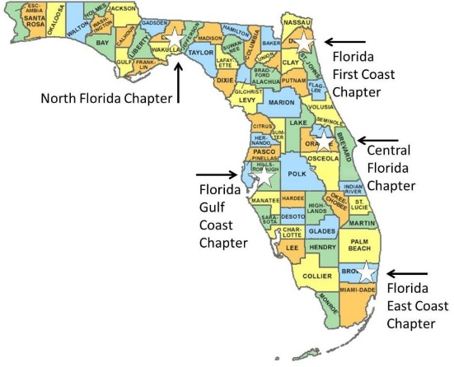
The Voice of Commercial Construction
www.abcflorida.com.

