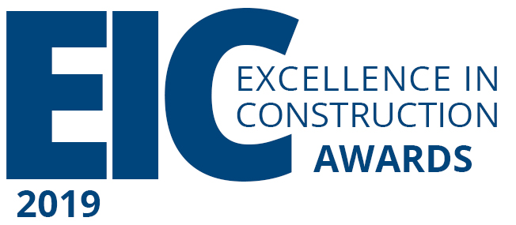

Entry Form

Or Apply Online:
pro.evalato.com/160/

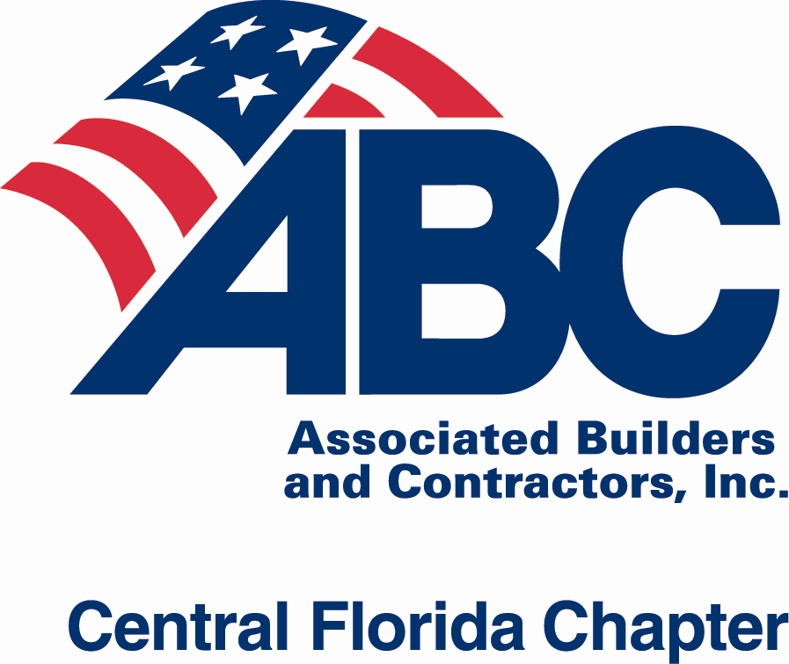

Deadlines:
Register Project (Part 1): April 30, 2019
Submit Final Application, Information and Payment (Part 2): May 15, 2019

Note: WDI, WDW, or Universal projects use separate designated entry form

CFC ABC EIC Project Entry Form 2019 – Part 1: Due April 30 Page 1 of 5

Complete all five pages of the entry form with the information exactly as it should appear in award-related materials. Each submission requires a separate entry form.

Questions? Call CFC ABC office 407.628.2070 or email eic@abccentralflorida.org.

CFC ABC Contractor Member Registration

This should be a person who will be accessible and readily available to answer questions and respond to emails from ABC Staff.

Company |  |  |  | GC Sub
Contact name |  |  | Title
Email |  | Office Phone | Cell Phone

Section I. Project Information
Project name
Project address (street, city, zip)
Project contract amount for your company
Start date / Completion date (c/o)
GC (if subcontractor entry)
Primary architect firm
Primary engineering firm
Owner/Client
Project team personnel names (no titles)
Percentage of work performed

Section II. Project Category

Project Dollar Amount Categories (Subcontractors, please note that project dollar and payment amount is determined based on your final contracted amount, not the entire amount for the project.)
Under $500,000  $500,000 - $1 million  $1 - $5 million  $5 - $10 million  $10 - $20 million | $20 - $50 million  $50 - $100 million  $100 - $250 million  Over $250 million | Select Payment Method:  Pay by check  Make checks payable to: Central Florida Chapter ABC  CFC ABC, 651 Danville Drive, Suite 200, Orlando, FL 32825  Pay online with credit card  Pay online at: abccentralflorida.com/EIC  Please send invoice  PO#: ___________________________  Email to send invoice: _____________________________
Entry Fees
Project Entry Fee may be paid by check, credit card, or online.
Project Dollar Amount - $0 to $20 million - $350
Project Dollar Amount – Over $20 million - $395

The application fee is non-refundable. Be sure to review the application Rules & Guidelines for eligibility prior to entering your submission.
*Projects are not eligible to be judged if payment has not been received by CFC ABC.
CFC ABC EIC Project Entry Form 2019 – Part 1: Due April 30 Page 2 of 5

Entry Type: General Contractor Subcontractor
Category
Subcontractors, select ONE category from the specialty work section
General Contractors, select ONE category from the building type section
Subcontractor/ Specialty Work
Concrete  Electrical  Exterior Finishes  Fire Protection  Furnishings/Interior Specialties  Glass & Glazing – Doors/windows  HVAC  Interior Finishes – Drywall, metal support assemblies, plaster, tile, terrazzo, ceilings, walls, floors, acoustical, paints, coatings (select one): ___________________________ |  | Landscape/Hardscape  Masonry, Precast or Stone  Plumbing  Site Work  Structural & Miscellaneous Metals  Thermal and Moisture Protection – Roofing  Wood & Millwork  Other Specialty Construction - Construction not specifically referred to in the above categories (theming, lighting protection, pools, building automation, special purpose rooms, etc.): __________________________
General Contactor/Building Type
Commercial - Office buildings, banks, retail, hotels, mixed use  Community Service – Philanthropic projects, regardless of type, that enhance the community, using substantial (35% +) resources donated by the contractor. Entries should include information detailing the donated resources  Entertainment Facilities – Theme parks, zoos, water parks, stadiums, sports arenas, etc.  Historical Renovation – Restoration of historical buildings  Health Care – Hospitals, nursing homes, assisted living, and other licensed medical facilities  Industrial – Manufacturing plants and facilities, refineries, and similar types of construction | Infrastructure: Heavy – Streets, highways, dams and bridges  Infrastructure: Light – Parks and community trails  Institutional – Projects owned by schools, churches and local governments with the exception of health care facilities  Interiors – Tenant build-out  Pre-engineered Buildings  Public Works/Environmental - Water treatment plants, sewage treatment plants  Residential/Multifamily – Residential, including independent living retirement communities, single family projects, multifamily, and condominiums  Other Construction – Construction not specifically referred to in the above categories: _______________________________________
If category is not listed or you are unsure, call Taylor at ABC 407.628.2070 or email eic@abccentralflorida.org for more clarification.

Hard Copy Entry Book
Will you be submitting a hard copy entry book?
Yes No TBD
• If yes, do not submit more than one copy. Hard copy entry books must be received by May 15, 2019 to be eligible for the Excellence in Marketing Award.

If you have any questions, do not hesitate to reach out to
Taylor Tidwell, Meetings and Events Director
Cami Coupland, Meetings and Events Coordinator
ABC Office: 407-628-2070
eic@abccentralflorida.org

CFC ABC EIC Project Entry Form 2019 – Part 2: Due May 15 Page 3 of 5

Company: _________________________________________ Project: _________________________________________________

Section III. Project Judging Information
Projects will be judged by either an on-site presentation or a presentation at the ABC office. If access cannot be obtained or if the project is located over 50 miles from the ABC office, a presentation will be scheduled at ABC.

Check One:
On-site Presentation (must be within 50 miles of the ABC office) Presentation at the ABC Office

- It is the responsibility of your company to contact the project site and relay the information to ABC
- If anything changes, please let ABC know as soon as possible

On-site Presentation Information
Have you contacted the project owner regarding a site visit for judging purposes? | Yes No, not yet
List the name, title and company of the person whom you contacted above and who approved the site visit. List the number that you reached them at. | Name: ____________________________________  Title: _____________________________________  Company: _________________________________  Phone number: _____________________________
Project Address
Address of meeting location for the judging team if different than the project address (i.e., work trailer address, backstage address, etc.)
Where at the site are you meeting the judging team (i.e. main entrance, parking lot D, inside gate, lobby, etc.)?
List any special driving directions (please include if back roads are taken).
*If the meeting location requires back roads or may be unclear, please include a map with a highlighted route from a main street to the meeting location. Note any land marks or signs to assist drivers in locating the meeting place.  * If project site is large, include an aerial map of the site and mark the meeting location. | Please see “Sample Map” on abccentralflorida.org/eic for examples of highlighted maps.
List any special parking instructions or descriptions.
List special requirements to gain access (i.e. must wear closed toed shoes, must enter in one car, must have ID, security requirements, etc.).

- Please designate a representative from your company to lead the presentation on-site or at ABC.
Lead Presenter Information
Name - As It Appears on Drivers’ License (IMPORTANT)
Title
Cell Phone
Email
Alternative Presenter Name - As It Appears on Drivers’ License
Title
Cell Phone
Email
Availability
Check ALL days that the lead presenters and project site (if an on-site presentation) are available. (Must check a minimum of two days and keep available.) | June 14 June 19 June 21  June 25 June 27 None  DISCLAIMER: Your presentation date is pending on judge’s availability – please let ABC know ASAP if your availability changes.
Note any additional information regarding availability, including time restrictions of presenters and project site (i.e. unavailable during lunch hours, visit prior to 9 AM, etc.).
CFC ABC EIC Project Entry Form 2019 – Part 2: Due May 15 Page 4 of 5

Company: _________________________________________ Project: _________________________________________________

Section IV. Safety
Did your company have a safety-related fatality? Yes No
If there was a safety related fatality, the applicant is not eligible.

 | Safety Questions | Yes | No | Attached? | (For ABC use)
1 | Has your company signed the Construction Coalition for Drug- and Alcohol-Free Workplace’s pledge at drugfreeconstruction.org? If no, please do.
2 | Does your company have a substance abuse policy?  If yes, include a one-page example or summary.
3 | Indicate number of OSHA lost-time accidents on this project: ____________
4 | Does your company have a written Safety and Health Policy Manual?  If yes, include a one-page summary or table of contents.
5 | Was a site-specific Safety and Health Policy Manual developed for this project?  If yes, include a one-page summary or table of contents.
6 | Does your company conduct a new employee safety orientation?  If yes, include a copy of the agenda.
7 | Were toolbox safety meetings held with employees and documented?  Frequency of meetings: ___________  If yes, include a one-page example or summary.
8 | Was there a daily job hazard analysis or a pre-task planning program throughout the duration of the project?  If yes, provide a one-page copy of the form.
9 | Was there a general safety site inspection program throughout the duration of the project?  If yes, please provide a one-page copy of the form.
10 | Was there a regular equipment inspection program (scaffolds, aerial lifts, etc.) throughout the duration of the project?  If yes, please provide a one-page example.
11 | Was specialized safety training or certifications conducted on this project?  If yes, include a one-page example or summary.
12 | Is there additional information regarding any innovative safety and health programs used on this project or the company’s overall safety program?  If yes, include examples or summaries.
13 | For general contractors or construction managers: Do you require accident reports from specialty contractors?  If yes, provide information on the process.
Total

Note: Required safety attachments must be received by May 15, 2019 in order to be included in the score.

SAFETY BONUS – 4 POINTS
STEP participation is not required but by completing the National STEP (Safety Training Evaluation Process) application and listing Central Florida Chapter ABC as a primary or additional chapter, you will earn an additional 4 points.

Safety Bonus points will count towards your project entry score if STEP application is completed by May 15, 2019.

Enter online: abc.org/en-us/safety/step.aspx.

CFC ABC EIC Project Entry Form 2019 – Part 2: Due May 15 Page 5 of 5

Company: _________________________________________ Project: _________________________________________________
Section V. Attachments
Submitted via Email Hard Copy Mailed CD/USB Drive Hard Copy Entry Book Other ______________

Scope – A one-page description of the work your company performed. Required.
Narrative - A one to five-page description on why your company deserves an award
Sub List – A complete list of subcontractors, suppliers and associates that your firm contracted for this project. Must be submitted to be considered for the Free Enterprise Award.
Photographs - 3 to 6 high resolution (300 dpi) in .jpg format - ABC uses submitted photos for the EIC Awards magazine and the on-screen presentation at the EIC Awards Banquet. Photos for judges’ viewing should be included in narrative or supplemental material.
Third-Party Signed Waiver
If any photos being submitted were taken by a third-party photographer, the photographer’s written authorization to use the photos is required. In order to comply, you must send ABC a copy of the signed licensing agreement found at abccentralflorida.org/EIC with the photographer’s signature. No changes are allowed to this document.
Safety attachments – Points awarded only If attachments are included.
Optional supplemental materials – such as recommendation letters, media coverage, other awards, etc.
Project Entry Rights and Agreement (see below)

Project Entry Rights and Agreement
All applicants are required to sign off on the following releases.

Property
All entries become the property of the Central Florida Chapter Associated Builders and Contractors (CFC ABC) and may be used for publication or any other promotional purpose CFC ABC deems appropriate. CFC ABC will retain the applicant’s entry as long as it is needed to fulfill program requirements. Entry books may be picked up at the ABC office after the EIC Awards Banquet.

Entry Category Reassignment
CFC ABC reserves the right to change an entry’s original category.

Grant of Rights
The applicant hereby grants to CFC ABC the following non-exclusive rights: the right to reproduce, distribute and sell copies of the work throughout the year as part of the course materials described above, including the right to reprint the work, or any part thereof, whenever necessary and to license the use of the work, or any part thereof, in any medium or form of communication; and the right to use the applicant’s name, photographs and biography, in connection with the work. The applicant reserves all rights not specifically granted herein.

Warranty
The applicant warrants that the work is original, that its publication will not infringe on the rights of others, and that it has the full power to make this grant.

Notification
Central Florida Chapter ABC Excellence in Construction Award winners will be notified after the judging process is complete.

Applicant Agreement
Enclosed are the project entry form and/or book that were prepared in accordance with the requirements indicated in this application.

I hereby give permission to the Central Florida Chapter Associated Builders and Contractors (CFC ABC) to use the photographs and any information submitted to the CFC ABC Excellence in Construction Awards competition pursuant to the terms of this agreement.

Print name: ________________________________________ Title: ___________________________________
Signature: _________________________________________ Date: ___________________________________
E-mail address: _____________________________________ Phone: __________________________________

