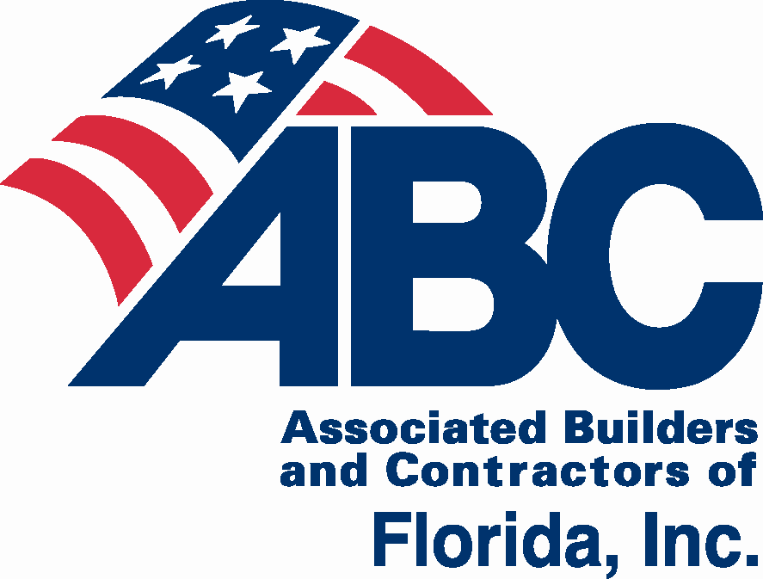**2018 ABC of Florida**

**State Convention**

**July 26-28, 2018**

This event supports state-wide legislative and political efforts for ABC members.

The ABC of Florida State Convention gives you an opportunity to make connections and develop relationships with peers from all five Florida ABC Chapters, while enjoying Florida’s gulf coast. Events are planned for business, couples, and families throughout the convention. Reserve your room for Thursday, Friday and Saturday nights at the JW Marriott Marco Island Resort.

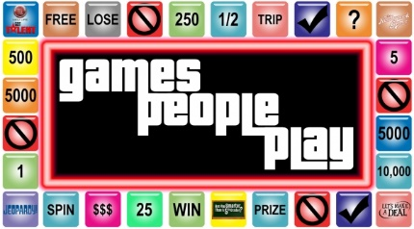

**2018 Convention Theme**

JW Marriott Marco Island

400 South Collier Blvd.

Marco Island, FL

# EVENT & ACTIVITIES SCHEDULE

Thursday, July 26 1:00 p.m. – 4:00 p.m. ABC of Florida Board Meeting

6:00 p.m. – 7:00 p.m. Opening Night & Legislative Reception

Friday, July 27 8:00 a.m. – 4:00 p.m. ABC of Florida Legislative Planning Conference

6:00 p.m. Chapter Dinners (Contact your Chapter Office)

Saturday, July 28 9:30 a.m. – 1:30 p.m. Day at the Beach & Beach Olympics

6:00 p.m. – 10:00 p.m. Reception, Dinner, Game Night

5:30 p.m. – 10:00 p.m. Children’s Night Out

**Convention details and link to room reservations:** [www.abccentralflorida.com/state-convention](http://www.abccentralflorida.com/state-convention)

**ABC of Florida State Convention Group Room Rates*:**

Run of the house $229

Gulf View room (based on availability) $259**

Suite (based on availability) $509**

Rates are available three days prior and three days after the event. The mandatory daily resort fee is discounted to $20 (valued at $154).

*Group rates are available for registered convention attendees.

** For discounted Gulf View or Suite, call the hotel directly at 1-800-438-4373.  Discounted rates for these two rooms are not available on the website.

**Deadline for Room at Group Rate:** Rooms are blocked and available at the group rate until **Monday, June 25, 2018**. After this date, there are no guarantees for availability and/or at group rate.

**Golf & Spa:** 10% discount on Golf and Spa Services for ABC members who reserve through room block.

**Parking:** Self-parking is $15 per car per day. Valet parking is $25 per car per day.

Sponsorship Opportunities

ABC of Florida State Convention • July 26-28, 2018

***Hospitality Suite Sponsorships***

***Thursday, July 26 – Saturday, July 28***

* Company logo on signage in hospitality room
* Snack sponsor has logo on snack bags

***–Beverage Sponsor $500***

***–Coffee Sponsor $500***

***–Snack Sponsor $500***

***ABC of FL Planning Conference Sponsor $500***

***Friday, July 27***

* Company logo on signage during planning conference

***Day at the Beach & Beach Olympics Sponsorships***

***Saturday, July 28***

* Company logo on signage during beach activities & displayed at final night event

***– Beach Olympics Sponsor $750***

***– Lunch Sponsor $500***

***– Paddle Board Competition Sponsor $250***

***– Kayak Race Sponsor $250***

***– Corn Hole Competition Sponsor $250***

***Opening Night &***

***Legislative Reception Sponsor $1,000***

***Thursday, July 26***

* Company logo on signage during reception

***Final Night Reception, Dinner &***

***Game Night Sponsorships***

***Saturday, July 28***

* Company logo on signage at final night

***– Reception Sponsor $1,000***

***– Gam*e *Show Sponsor $1,000***

***– Centerpiece Sponsor $500***

**– *Win it* *Challenges Sponsor $250***

***– Selfie Photo Booth* *Sponsor $250***

***Registration Package Sponsor $125***

* Items supplied by your company will be included in attendees’ registration package or displayed at registration and in hospitality suite

(send 150 donated items)

* Contact the CFC ABC office with specifics, regarding shipping, delivery, size, etc., as there may be additional charges.

***In addition sponsors will receive:***

* Listing in the convention package with company logo (high resolution company logo required) or name
* After event, Sponsors’ company logos will appear on the email sent to participants with the website link to convention photos
* $1,000 sponsors will have the opportunity to speak during the final night event

 □ Central FL □ East Coast □ First Coast □ Gulf Coast □ North FL

Company ______________________________________________ Contact ___________________________

Phone ____________________________ Email _______________________________________________

**Sponsorship:** _____________________________________________________ $_________________________

**Payment Options:** □ Check enclosed □ Sending check (by July 1) □ Request Invoice P.O. # □ Visa □ MC □ AMEX □ Discover

Name on Card Card # Exp. Date

CVC Code _________ Statement Address Statement Zip Code

Payable to: ABC of Florida, 651 Danville Drive, Suite 200, Orlando, FL 32825

Email [RSVP@abccentralflorida.org](mailto:RSVP@abccentralflorida.org), Fax 407.629.0144

Online at: [www.abccentralflorida.com/state-convention](http://www.abccentralflorida.com/state-convention)

***For more information contact:*** Nancy Wray, 407.628.2070, nwray@abccentralflorida.org

**ABC of Florida State Convention**

Registration & Sponsorship Form

**JW Marriott Marco Island Beach Resort | 400 S. Collier Blvd. | Marco Island, FL 34145**

|  |  |
| --- | --- |
| Chapter (Check one):  □ Central FL □ East Coast □ First Coast □ Gulf Coast □ North FL |  |
| CONTACT PERSON’S NAME | PHONE |
| CONTACT PERSON’S COMPANY | E-MAIL |

|  |  |  |
| --- | --- | --- |
| 2018 | **Schedule** |  |
| Thursday, July 26 | 11:00 a.m. – 5:00 p.m.  1:00 p.m. – 4:00 p.m. | Registration & Hospitality Suite  Hospitality Suite is open to all convention registrants. The Suite will have morning coffee & danish, water, soda, and snacks for your enjoyment.  ABC of FL Board Meeting |
|  | 6:00 p.m. – 7:00 p.m.  7:00 p.m. – 7:30 p.m. | Opening Night & Legislative Reception  Registration & Hospitality Suite |
| Friday, July 27 | 7:30 a.m. – 4:00 p.m. | Registration & Hospitality Suite |
|  | 8:00 a.m. – 4:00 p.m. | ABC of FL Legislative Planning Conference |
|  | 6:00 p.m. | Chapter Dinners (check with your Chapter Rep.) |
| Saturday, July 28 | 9:30 a.m. – 1:30 p.m. | Day at the Beach & Beach Olympics |
|  | 6:00 p.m. – 10:00 p.m. | Reception, Dinner & Game Night |
|  | 5:30 p.m. – 10:00 p.m. | Children’s Night Out |

1. Convention Package $450 – includes Opening Night Reception, Day at the Beach & Beach Olympics, Final Night Reception & Dinner Party

2. Planning Conference $100 – includes coffee, beverages, & lunch

3. Planning Conference Package $200 – includes planning conference and Opening Night & Legislative Reception (Special for PC attendees!)

Individual Events:

4. Opening Night & Legislative Reception $150

5. Day at the Beach & Beach Olympics (12-Adult) includes lounge $50

6. Day at the Beach (4-11) without lounge $25 (upgrade to add lounge additional $25)

7. Reception, Dinner & Game Night $275

8. Children’s Night Out $99 – Ages 5-12 Children – deadline to register is Thursday, July 26, 5 p.m.

**Registration on the day of any event/walk-in rate will include a 20% late fee as follows:**

#1 - $540, #2 - $120, #3 - $240, #4 - $180, $5 - $60, #6 - $30, #7 -$330

Codes: M= ABC member company employee; S = Significant Other/Spouse/Guest of ABC member (Adult/Teen); C – Child 11 & under

|  |  |  |  |  |  |  |  |
| --- | --- | --- | --- | --- | --- | --- | --- |
| M/S | Name (please print/type for badges): | | Email – please include email for all adults to receive updates and other notices | Mobile #) | Event(s) or Package – please circle item numbers | Child  Age | Total per person |
|  |  | |  |  | 1 2 3 4 5 6 7 8 |  | **$** |
|  |  | |  |  | 1 2 3 4 5 6 7 8 |  | **$** |
|  |  | |  |  | 1 2 3 4 5 6 7 8 |  | **$** |
|  |  | |  |  | 1 2 3 4 5 6 7 8 |  | **$** |
|  |  | |  |  | 1 2 3 4 5 6 7 8 |  | **$** |
|  |  | |  |  | 1 2 3 4 5 6 7 8 |  | **$** |
|  |  | |  |  | 1 2 3 4 5 6 7 8 |  | **$** |
|  |  |  | | | | **Sub Total =** | **$** | |
|  |  | □ Yes, sign me up for an ABC of FL State Convention Sponsorship | | | | **Sponsorship** | **$** | |
|  |  |  | | | | **Total =** | **$** | |

**Cancellation Policy**: Cancellations received by 5 p.m., 7/23/18 will be accepted and a cancellation number will be given for confirmation. After this date, no refunds will be issued.

**Payment Options:** □ Check enclosed □ Sending check (by July 1) □ Request Invoice P.O. # □ Visa □ MC □ AMEX □ Discover

Name on Card Card # Exp. Date

CVC Code _________ Statement Address Statement Zip Code

Email receipt to _________________________________________________________________ Phone ________________________________________

⦁ Payable and mail to: ABC of Florida, 651 Danville Drive, Suite 200, Orlando, FL 32825

⦁ Email [RSVP@abccentralflorida.org](mailto:RSVP@abccentralflorida.org), Fax 407.629.0144

⦁ Online at: <https://www.abccentralflorida.com/state-convention/>

**2018 ABC of Florida State Convention Program**

Thursday, July 26, 6:00 p.m.

Opening Night & Legislative Reception

Join us for opening night reception. Make connections; build relationships while snacking and sipping in Caxambas overlooking the beach and gulf coast waters.

Friday, July 27, 8:00 a.m. – 4:00 p.m.

ABC of Florida Legislative Planning Conference

All ABC members welcome to participate! Agenda to follow.

Chapter Dinners, 6:00 p.m.

Check with your Chapter Representative for more details.

Saturday, July 28, 9:30 a.m. – 1:30 p.m.

Day at the Beach & Beach Olympics

Activities will include paddleboard relay race, kayak race, volleyball, corn hole tournament, along with beach games including Kan Jam, and Spike Ball. Relax in one of the water hammocks or sign up to participate in the Beach Olympics wacky events– from Flipper Frenzy to a relay Obstacle Course, this competition will prove to be the event to watch!

The Marco Island Marriott staff will have lounge chairs and umbrellas ready for the ABC group to kick back, relax, and watch the fun or join in the competition! Included: Music, beverages, sandwiches, snacks, and kids’ beach toys – all at the ABC tent area.

Reception, Dinner & Game Night, 6:00 – 10:00 p.m.

After a fabulous three course buffet dinner, the entertainment will begin with ABC of FL’s game show! There will be “Minute To Win It” challenges where everyone is invited to play. Join the fun or just watch the hilarious antics, but plan to be here on the final night of the State Convention!

Casual dress is appropriate, as is dressing for fun for ABC of FL’s Game Night.

Children’s Night Out, 5:30 – 10:00 p.m.

This four-hour Marriott evening program is appropriate for children ages 5 to 12. Children will spend an evening in Marriott’s private Tiki Tribe camp and participate in a variety of exciting, educational and creative activities. Dinner is included along with a sweet treat from Menchies. Camp is located next to Menchies in the Islands Tower. If registrations exceed 16 children, the camp will be located one of the Marriott ballrooms near ABC registration and hospitality room.

**Family Support Services**

**CHILDREN’S PROGRAMS THROUGH JW MARRIOTT**

**Tiki Tribe Discover Day Camp**

Sometimes you just need a little adult time to relax, recharge, and rejuvenate. And kids need time on their own to have fun, make new friends, and explore. The JW Marriott Marco Island’s Tiki Tribe Discovery Day Camp offers peace of mind for parents and tons of fun for kids. The Tiki Tribe Discovery Day Camp invites kids to become wildlife explorers in a small, nurturing day camp setting. Campers are led by Marriott-trained activity coordinators while participating in a wide range of resort activities which may include scavenger hunts, games, toys, arts & crafts and more.

## Available 10 a.m. – 3 p.m. daily, for children ages 5 - 12 years. Cost: $70/child ($60 each additional child from the same family), includes lunch. Call JW Marriot Beach & Recreation at 1-239-642-2740 for reservations.

### Nanny Services

JW Marriott Marco Island can easily arrange a nanny as part of our variety of services. A contract from the concierge desk must be signed prior to securing a nanny. There will be one nanny assigned to each family for a three-hour minimum. For more information, contact our Personal Vacation Planning department at 1-800-638-8410 or via e-mail at [stella.spera@marriott.com.](mailto:stella.spera@marriott.com.?subject=Nanny%20Service)

**THINGS TO DO IN MARCO ISLAND:** [marriott.com/hotels/local-things-to-do/mrkfl-jw-marriott-marco-island-beach-resort](http://www.marriott.com/hotels/local-things-to-do/mrkfl-jw-marriott-marco-island-beach-resort/)

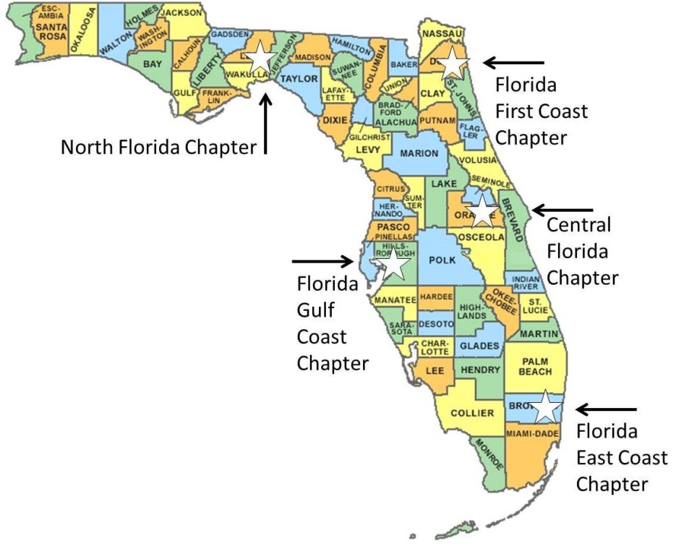

**ABOUT ABC OF FLORIDA**

**ABC has the strongest network of commercial and industrial contractors in the state of Florida with five chapter offices serving over 2,000 companies in every major construction market.   
  
No one protects you and your business’ legislative and regulatory rights as well as ABC, while providing apprenticeship, skills, management and safety training, networking, member discounts, and many other benefits.**

|  |  |  |
| --- | --- | --- |
| **North Florida Chapter**  (including Tallahassee & Pensacola)  **Angie Brooke**  President & CEO  [brooke@abcnorthflorida.org](mailto:brooke@abcnorthflorida.org)  1535 Killearn Center Blvd.,  Suite B-1  Tallahassee, Florida 32309  Phone: 850.385.0060  [www.abcnorthflorida.org](http://www.abcnorthflorida.org) | **Florida First Coast Chapter**  (including Jacksonville &  St. Augustine)  **Karin Tucker**  [ktucker@abcfirstcoast.com](mailto:ktucker@abcfirstcoast.com)  President & CEO  707 Peninsular Place, Suite 100  Jacksonville, Florida 32204  Phone: 904.731.1506  [www.abcfirstcoast.com](http://www.abcfirstcoast.com/) | **Florida Gulf Coast Chapter**  (coastal counties from Ft. Myers to Tampa plus Gainesville)  **Steve Cona III**  [stevecona3@abcflgulf.org](mailto:stevecona3@abcflgulf.org)  President & CEO  2008 North Himes Ave.  Tampa, Florida 33607  Phone: 813.879.8064  www.abcflgulf.org |
| **Central Florida Chapter**  (including Orlando, Kissimmee & Daytona Beach)  **Mark P. Wylie**  [mwylie@abccentralflorida.org](mailto:mwylie@abccentralflorida.org)  President & CEO  651 Danville Drive, Suite 200  Orlando, Florida 32825-6393  Phone: 407.628.2070  [www.abccentralflorida.com](http://www.abccentralflorida.com/) | **Florida East Coast Chapter**  (coastal counties from Brevard to Key West including Miami, Ft. Lauderdale and West Palm Beach)  **Peter Dyga**  [pdyga@abceastflorida.com](mailto:pdyga@abceastflorida.com)  President & CEO  3730 Coconut Creek Parkway, Suite 200  Coconut Creek, Florida 33066  Phone: 954.984.0075  [www.abceastflorida.com](http://www.abceastflorida.com/) |  |

**The Voice of Commercial Construction**

**www.abcflorida.com**