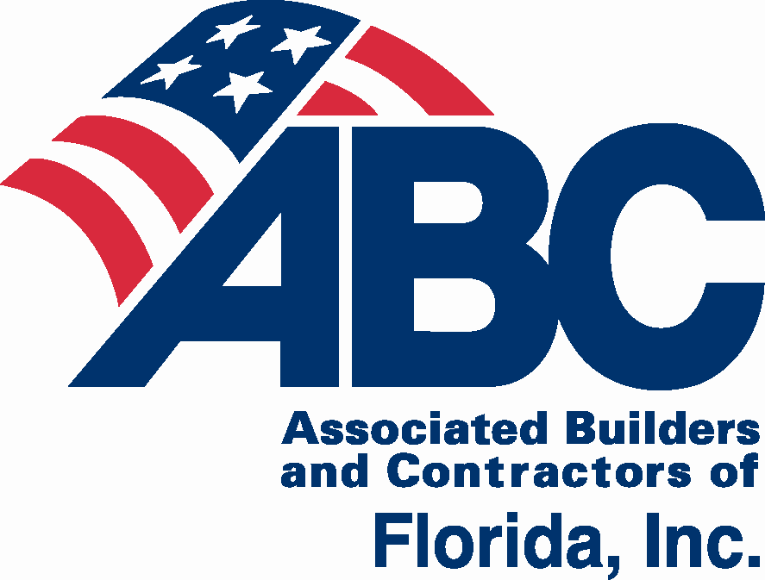2017 ABC of Florida
State Convention
July 27-29, 2017
This event supports state-wide legislative and political efforts for ABC members.

The ABC of Florida State Convention gives you an opportunity to make connections and develop relationships with peers from all five Florida ABC Chapters, while enjoying the Florida’s gulf coast. Events are planned for business, couples, and families. Reserve your room for Thursday, Friday and Saturday nights at the JW Marriott Marco Island Resort.

JW Marriott Marco Island
400 South Collier Blvd.
Marco Island, FL

EVENT SCHEDULE
Thursday, July 27 2:00 p.m. – 3:00 p.m. 2020 Task Force
3:00 p.m. – 5:00 p.m. ABC of FL Board Meeting
6:00 p.m. – 7:00 p.m. Opening Night Reception
7:00 p.m. Dinner on your own
Friday, July 28 8:00 a.m. – 3:00 p.m. Planning Conference
(Includes breakfast & lunch)
6:00 p.m. Chapter Dinners (Check with your Chapter Representative)
Saturday, July 29 9:00 a.m. – 1:00 p.m. Day at the Beach
6:00 p.m. – 10:00 p.m. Viva Las Vegas Casino Night Dinner Party
5:30 p.m. – 10:00 p.m. Children’s Night Out

Convention details and link to room reservations: abccentralflorida.com/2017-state-convention.

The ABC of Florida State Convention group room rate is $219 for the convention run of the house room. Gulf view rooms are on an available only basis at $249. For discounted suites (based on availability) call the hotel directly at 1-800-GET-HERE. They are not available on the website.
Rates are available 3 days pre and post event. The mandatory daily resort fee of $25 (valued at $154) has been changed to an optional add on at check-in.

Deadline: Rooms are blocked and available at the group rate until June 26, 2017. After this date, there are no guarantees for availability and/or at group rate.
Golf & Spa: 10% discount on Golf and Spa Services for ABC members who reserve through room block.
Parking: Self-parking is discounted to $8 per car per day. Valet parking is $25 per car per day.
Sponsorship opportunities: Call 407-628-2070, or email nwray@abccentralflorida.org

Sponsorship Opportunities
ABC of Florida State Convention July 27-29, 2017

Hospitality Suite
Thursday, July 27 – Saturday, July 29
- Company logo on signage in hospitality room
- Snack sponsor has logo on snack bags
–Beverage Sponsor $500
–Coffee Sponsor $500
–Snack Sponsor $500

Opening Night Reception $1,000
Thursday, July 27
- Company logo on signage during reception

Day at the Beach
Saturday, July 29
- Company logo on signage during beach activities

– Volley Ball Sponsor $500

– Paddle Board Sponsor $500

– Lunch Sponsor $500

– Corn Hole Sponsor $250
Final Night Viva Las Vegas Casino Dinner Party
Saturday, July 29
- Company logo on signage at final night
– Reception Sponsor $1,000

– Centerpiece Sponsor $500
– Casino Game Table Sponsor $250
Company logo on gaming table tent card
– Raffle Prize Sponsor $250
Company name or logo by sponsored item

Children’s Night Out Sponsor $250
Saturday, July 29
- Company logo on convention signage

Registration Package Sponsor $100
- Items supplied by your company will be included in attendees’ registration package or displayed at registration and in hospitality suite (150 items)
- Contact the CFC ABC office with specifics, regarding shipping, delivery, size, etc., as there may be additional charges.

In addition sponsors will receive:
- Listing in the convention package with company logo (high resolution company logo required) or name
- After event, company logo on email to participants with link to photos
- $1,000 sponsors will have the opportunity to speak during the final night event
Central FL East Coast First Coast Gulf Coast North FL
Company ______________________________________________ Contact ___________________________
Phone ____________________________ Email _______________________________________________
Sponsorship: _____________________________________________________ $_________________________
Payment Options: Check enclosed Sending check (by July 1) Request Invoice P.O. # Visa MC AMEX Discover
Name on Card Card # Exp. Date
CVC Code _________ Statement Address Statement Zip Code

Payable to: ABC of Florida PC, 651 Danville Drive, Suite 200, Orlando, FL 32825
Email RSVP@abccentralflorida.org, Fax 407.629.0144
Online at: abccentralflorida.com/2017-state-convention
For more information contact: Nancy Wray, 407.628.2070, nwray@abccentralflorida.org
ABC of Florida State Convention
Registration & Sponsorship Form

JW Marriott Marco Island Beach Resort | 400 S. Collier Blvd. | Marco Island, FL 34145

Chapter (Check one):
Central FL East Coast First Coast Gulf Coast North FL
CONTACT PERSON’S NAME | PHONE
CONTACT PERSON’S COMPANY | E-MAIL
2017 | Schedule
Thursday, July 27 | 11:00 a.m. – 5:00 p.m.  2:00 p.m. – 3:00 p.m.  3:00 p.m. – 5:00 p.m. | Registration & Hospitality Suite  Hospitality Suite is open all convention registrants. The Suite will have morning coffee & Danish, waters & sodas, and snacks for your enjoyment.  2020 Task Force Meeting  ABC of FL Board Meeting
 | 6:00 p.m. – 7:00 p.m.  7:00 p.m. – 7:30 p.m. | Opening Night Reception  Registration & Hospitality Suite
Friday, July 28 | 7:30 a.m. – 4:00 p.m. | Registration & Hospitality Suite
 | 8:00 a.m. – 3:00 p.m. | Planning Conference
 | 6:00/7:00 p.m. | Chapter Dinners (check with your Chapter Rep.)
Saturday, July 29 | 9:00 a.m. – 1:00 p.m. | Day at the Beach
 | 6:00 p.m. – 10:00 p.m. | Viva Las Vegas Casino Dinner Party
 | 5:30 p.m. – 10:00 p.m. | Children’s Night Out
1. Convention Package $450 – includes Opening Night Reception, Day at the Beach, Viva Las Vegas Casino Dinner Party
2. Planning Conference $150 – includes breakfast and lunch
3. Planning Conference Package $250 – includes planning conference and Opening Night Reception
Individual Events:
4. Opening Night Reception $150
5. Day at the Beach (12-Adult) includes lounge $50
6. Day at the Beach (4-11) without lounge $25 (upgrade to add lounge additional $25)
7. Viva Las Vegas Casino Dinner Party $275 (18 & up)
8. Children’s Night Out $99 – Ages 5-12 Children – deadline to register is Thursday, July 27, 5 p.m.
9. Teen’s Night Out $99 – Ages 13-17 – deadline to register is Friday, July 21
Deadline to register: For reservations after 5 p.m. July 19, including walk-ins at each event, there will be 20% late fee.
Pricing after July 19 – 1. $540, 2. $180, 3. $300, 4. $180, 5. $60, 6. $30, 7. $330, 8. $118.80, 9. $118.80
M/S – M= ABC member company employee; S = Significant Other/Spouse/Guest of ABC member
M/S | Name (please print/type for badges): | Email – please include email for all adults | Event(s) or Package – please circle item numbers |  |  | Child  Age | Total per person
 |  |  | 1 2 3 4 5 6 7 8 9 |  |  |  | $
 |  |  | 1 2 3 4 5 6 7 8 9 |  |  |  | $
 |  |  | 1 2 3 4 5 6 7 8 9 |  |  |  | $
 |  |  | 1 2 3 4 5 6 7 8 9 |  |  |  | $
 |  |  | 1 2 3 4 5 6 7 8 9
 |  |  | 1 2 3 4 5 6 7 8 9
 |  |  | 1 2 3 4 5 6 7 8 9 |  |  |  | $
 |  |  |  |  | Sub Total = |  | $
 | Yes, sign me up for an ABC of FL State Convention Sponsorship |  |  |  | Sponsorship = |  | $
 |  |  |  | Total = |  |  | $

Payment Options: Check enclosed Sending check (by July 1) Request Invoice P.O. # Visa MC AMEX Discover
Name on Card Card # Exp. Date
CVC Code _________ Statement Address Statement Zip Code
Email receipt to _________________________________________________________________ Phone ________________________________________
Payable and mail to: ABC of Florida PC, 651 Danville Drive, Suite 200, Orlando, FL 32825
Email RSVP@abccentralflorida.org, Fax 407.629.0144
Online at: abccentralflorida.com/event/abc-of-florida-state-convention
2017 ABC of Florida State Convention Program
Thursday, July 27, 6:00 p.m.
Opening Night Reception
Join us for opening night reception. Make connections; build relationships while snacking and sipping in Caxambas overlooking the beach and gulf coast waters.
Friday, July 28, 8:00 a.m. – 3:00 p.m.
Planning Conference
Agenda to follow.
Chapter Dinners
Check with your Chapter Representative for more details.
Saturday, July 29, 9:00 a.m. – 1:00 p.m.
Day at the Beach
Activities will include paddleboard race, volleyball tournament, corn hole tournament, along with beach games including Kan Jam, and Spike Ball. There will be kayaks (single and double seaters), and water hammocks, too. The Marco Island Marriott staff will have lounge chairs and umbrellas ready for the ABC group to kick back, relax, and watch the fun or join in the competition! Music, beverages, sandwiches, snacks, and kids’ beach toys will be available at the ABC tent area.
Viva Las Vegas Casino Dinner Party, 6:00 – 10:00 p.m.
After a fabulous three course buffet dinner, the Casino tables will be open with blackjack, roulette, craps, and poker tables ready for gaming. Everyone will start with vouchers which can be exchanged for gaming chips. At the end of the evening, these chips are converted to raffle tickets which are for $2,000+ in raffle prizes. Casual dress is appropriate, as is dressing with the theme of “Viva Las Vegas.” 18 & UP ONLY.
Children’s Night Out, 5:30 – 10:00 p.m.
This four-hour Marriott evening program is appropriate for children ages 5 to 12. Children will spend an evening in Marriott’s private Tiki Tribe camp and participate in a variety of exciting, educational and creative activities. Dinner is included along with a sweet treat from Menchies. Camp is located next to Menchies in the Islands Tower. If registrations exceed 16 children, the camp will be located one of the Marriott ballrooms near ABC registration and hospitality room.
Teen’s Escape, 5:30 – 9:00 p.m.
This Saturday evening field trip for teens will include a trip to the Marco Island Escape Room, located three miles from JW Marriott. Marriott will transport teens in a 12 passenger van to Extreme Escape, a real life escape room. Rooms are filled with riddles, mind tricks and puzzles that participants will have 60 minutes to solve in order to escape. Afterwards, group will return to JW Marriott for dinner.

Amenities
CHILDREN’S PROGRAMS THROUGH JW MARRIOTT
Tiki Tribe Discover Day Camp
Sometimes you just need a little adult time to relax, recharge, and rejuvenate. And kids need time on their own to have fun, make new friends, and explore. The JW Marriott Marco Island’s Tiki Tribe Discovery Day Camp offers peace of mind for parents and tons of fun for kids. The Tiki Tribe Discovery Day Camp invites kids to become wildlife explorers in a small, nurturing day camp setting. Campers are led by our own Marriott-trained activity coordinators while participating in a wide range or resort activities which may include a scavenger hunt, games, toys, arts & crafts and more.

Available 10 a.m. – 3 p.m. daily, for children ages 5 - 12 years. Cost: $70/child ($60 each additional child from the same family), includes lunch. Call JW Marriot Beach & Recreation at 1-239-642-2740 for reservations.

Nanny Services
JW Marriott Marco Island can easily arrange a nanny as part of our variety of services. A contract from the concierge desk must be signed prior to securing a nanny. There will be one nanny assigned to each family for a three-hour minimum. For more information, contact our Personal Vacation Planning department at 1-800-638-8410 or via e-mail at stella.spera@marriott.com.

THINGS TO DO IN MARCO ISLAND: marriott.com/hotels/local-things-to-do/mrkfl-jw-marriott-marco-island-beach-resort

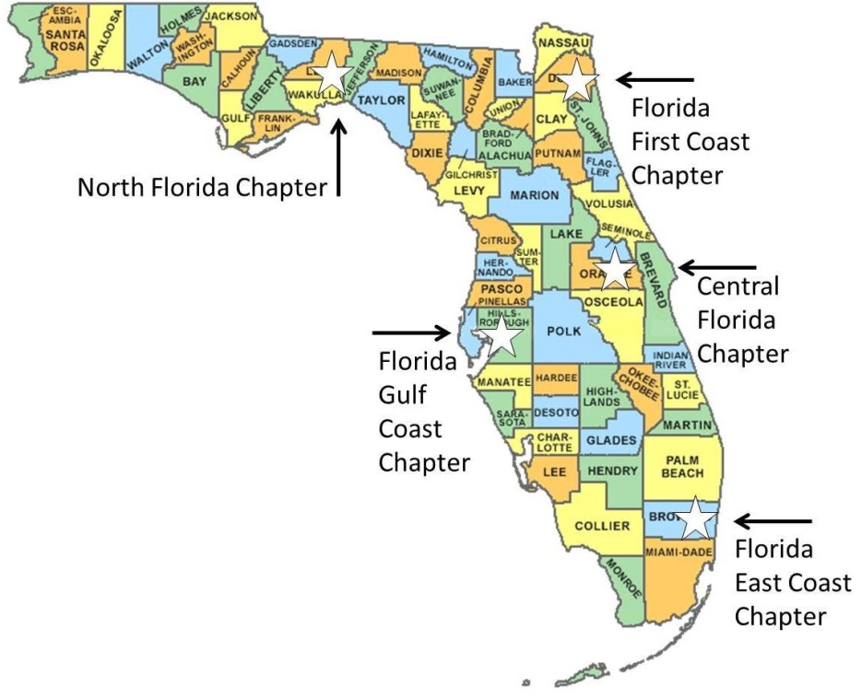

ABOUT ABC OF FLORIDA
ABC has the strongest network of commercial and industrial contractors in the state of Florida with five chapter offices serving over 2,000 companies in every major construction market.
No one protects you and your business’ legislative and regulatory rights as well as ABC, while providing apprenticeship, skills, management and safety training, networking, member discounts, and many other benefits.

North Florida Chapter  (including Tallahassee & Pensacola)  Angie Brooke  President & CEO  brooke@abcnorthflorida.org  1535 Killearn Center Blvd.,  Suite B-1  Tallahassee, Florida 32309  Phone: 850.385.0060  www.abcnorthflorida.org | Florida First Coast Chapter  (including Jacksonville &  St. Augustine)  Karin Tucker  ktucker@abcfirstcoast.com  President & CEO  707 Peninsular Place, Suite 100  Jacksonville, Florida 32204  Phone: 904.731.1506  www.abcfirstcoast.com | Florida Gulf Coast Chapter  (coastal counties from Ft. Myers to Tampa plus Gainesville)  Steve Cona III  stevecona3@abcflgulf.org  President & CEO  2008 North Himes Ave.  Tampa, Florida 33607  Phone: 813.879.8064  www.abcflgulf.org
Central Florida Chapter  (including Orlando, Kissimmee & Daytona Beach)  Mark P. Wylie  mwylie@abccentralflorida.org  President & CEO  651 Danville Drive, Suite 200  Orlando, Florida 32825-6393  Phone: 407.628.2070  www.abccentralflorida.com | Florida East Coast Chapter  (coastal counties from Brevard to Key West including Miami, Ft. Lauderdale and West Palm Beach)  Peter Dyga  pdyga@abceastflorida.com  President & CEO  3730 Coconut Creek Parkway, Suite 200  Coconut Creek, Florida 33066  Phone: 954.984.0075  www.abceastflorida.com

The Voice of Commercial Construction
www.abcflorida.com

